REAL TIME OBJECT MEASUREMENT in Images using SVM (Support Vector Machine)

Title-1
Improved accuracy in real time object measurement using Support Vector Machine in comparison with SSD (Single Short Multi box Detector) algorithm.

PICO:
Problem: Less accuracy in real time object measurement
Intervention: Support Vector Machine
Comparison: Single Short Multi box Detector
Outcome: Improved accuracy

Title-2
Improved accuracy in real time object measurement using Support Vector Machine in comparison with Random forest algorithm.

PICO:
Problem: Less accuracy in real time object measurement
Intervention: Support Vector Machine
Comparison: Random forest algorithm
Outcome: Improved accuracy

Title-3
Improved accuracy in real time object measurement using Support Vector Machine in comparison with EfficientDet algorithm.

PICO:
Problem: Less accuracy in real time object measurement
Intervention: Support Vector Machine
Comparison: EfficientDet algorithm.
Outcome: Improved accuracy

Title-4
Improved accuracy in real time object measurement using Support Vector Machine in comparison with mask RCNN algorithm.

PICO:
Problem: Less accuracy in real time object measurement
Intervention: Support Vector Machine
Comparison: Mask RCNN algorithm
outcome: Improved accuracy.

TABLE:
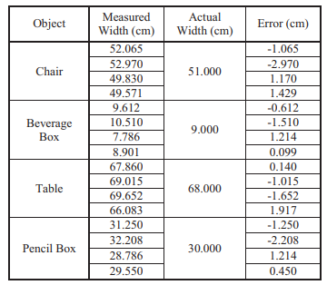

Sample size:


